DSA06 – DATA HANDLING AND VISUALIZATION

Field | Details
Department | AIDS
Course Code / Course Name | DSA0602 / Data Handling and Visualization
ASSESMENT | CO1-AT1
Name | B Mallika
Register Number | 192324234
Date | 06-10-2026
Day | Tuesday

Q1. R Code to Visual: Polar coordinates [10 marks]
library(ggplot2) Read the R program carefully. Do not run it.
df <- data.frame(
Month = c("Jan", "Feb", "Mar", "Apr", "May", "Jun", "Jul", "Aug", "Sep", "Oct", "Nov", "Dec"),
Units_Sold = c(100, 70, 60, 50, 40, 50, 100, 30, 30, 30, 70, 70)
)
df$Month <- factor(df$Month, levels = df$Month)
ggplot(df, aes(x = Month, y = Units_Sold)) +
geom_col(fill = "steelblue", width = 1) +
coord_polar() +
scale_y_continuous(limits = c(0, 100))

(a) Sketch the chart produced. Show the angle labels and the radial scale. [5]
- The chart is a polar/radial bar chart with 12 equal sectors, one for each month from Jan to Dec.
- The angle around the circle represents the Month. Each month occupies 360° ÷ 12 = 30°.
- The radius represents Units_Sold, with the scale running from 0 to 100.
- The tallest bars are Jan and Jul at 100 units. The shortest bars are Aug, Sep and Oct at 30 units.
- All bars use the same steel-blue fill because the R code specifies fill = "steelblue".
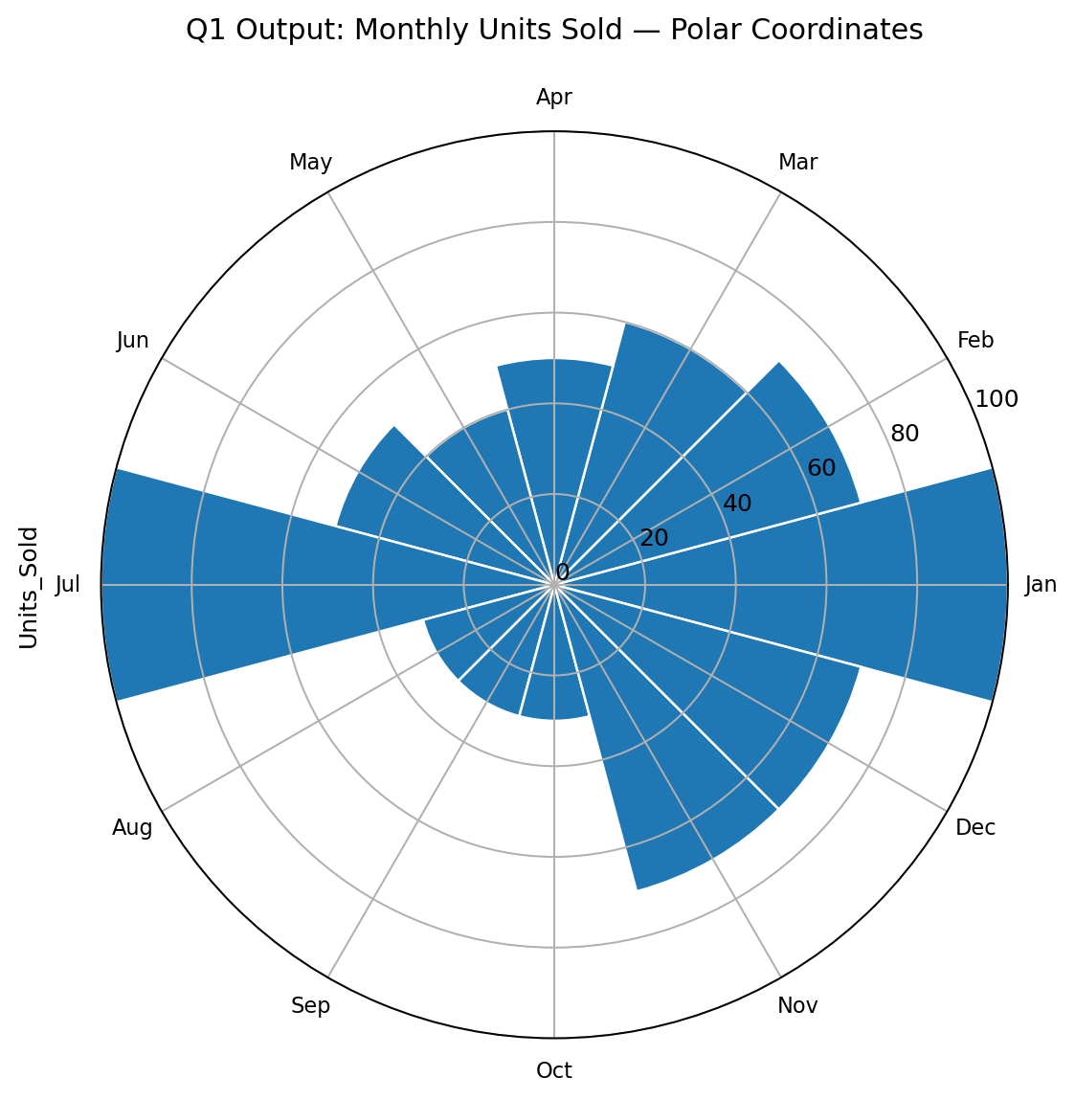

(b) State what angle and radius encode, and name the coordinate system. [3]
- Angle / angular position: encodes Month, a categorical/ordered time variable.
- Radius / distance from the centre: encodes Units_Sold, a quantitative value.
- Coordinate system: polar coordinates, created by coord_polar().

(c) Which change in the code gives the same data as an ordinary Cartesian bar chart? [2]
- Remove the line coord_polar().
- The resulting ggplot with geom_col() uses the ordinary Cartesian coordinate system.
ggplot(df, aes(x = Month, y = Units_Sold)) +
geom_col(fill = "steelblue", width = 1) +
scale_y_continuous(limits = c(0, 100))

Q2. Visual to Table: Reading a polar chart [10 marks]
The polar bar chart shows electricity demand (MW) for 8 time slots. Radial grid lines are at 0, 20, 40, ... 100.

(a) Reconstruct the table (Time_slot, Energy_MW). [5]
Time_slot | Energy_MW
0h | 60
3h | 100
6h | 40
9h | 20
12h | 30
15h | 50
18h | 60
21h | 80
- The values are read from the radial grid lines. For example, the 3h bar reaches 100 MW, while the 9h bar reaches 20 MW.
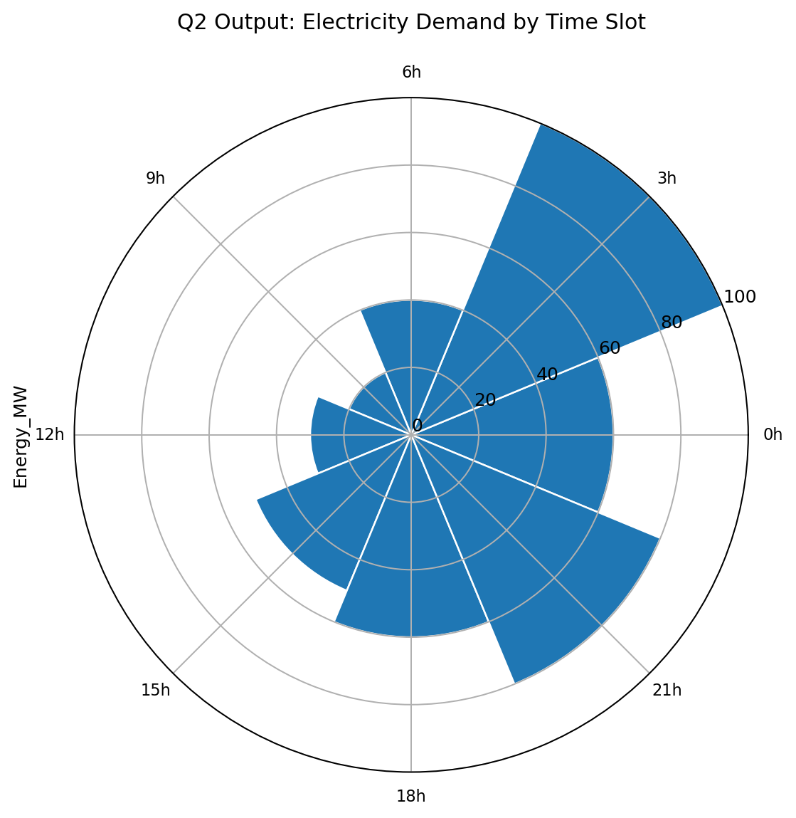

(b) Name the peak and the lowest time slot, and give the angle between adjacent bars. [3]
- Peak: 3h, with 100 MW.
- Lowest: 9h, with 20 MW.
- There are 8 equal time slots, so the angle between adjacent bars is 360° ÷ 8 = 45°.

(c) State one advantage and one drawback of using polar coordinates here. [2]
- Advantage: polar coordinates naturally show the cyclical 24-hour sequence and make the time cycle visually continuous.
- Drawback: comparing exact bar lengths is harder than in a standard Cartesian bar chart because the bars are arranged around a circle.

Q3. Visual to R Code: Colour as a tool to highlight [10 marks]
Branch / Sales_Lakh table: Jaipur 300; Mumbai 730; Kochi 395; Chennai 685; Pune 470; Kolkata 235.

(a) Write the complete R program (data frame, highlight logic and ggplot call). [7]
library(ggplot2)
df <- data.frame(
Branch = c("Jaipur", "Mumbai", "Kochi", "Chennai", "Pune", "Kolkata"),
Sales_Lakh = c(300, 730, 395, 685, 470, 235)
)
df$Top <- df$Sales_Lakh == max(df$Sales_Lakh)
ggplot(df, aes(x = reorder(Branch, Sales_Lakh),
y = Sales_Lakh, fill = Top)) +
geom_col() +
coord_flip() +
scale_fill_manual(values = c("FALSE" = "grey70",
"TRUE" = "#D55E00")) +
guides(fill = "none")
- The data frame stores branch names and their sales values.
- The Top column is TRUE only for the branch whose Sales_Lakh equals the maximum value.
- reorder(Branch, Sales_Lakh) sorts the bars by sales, and coord_flip() makes the bars horizontal.
- scale_fill_manual() assigns grey to ordinary bars and an accent colour to the highest-sales bar.
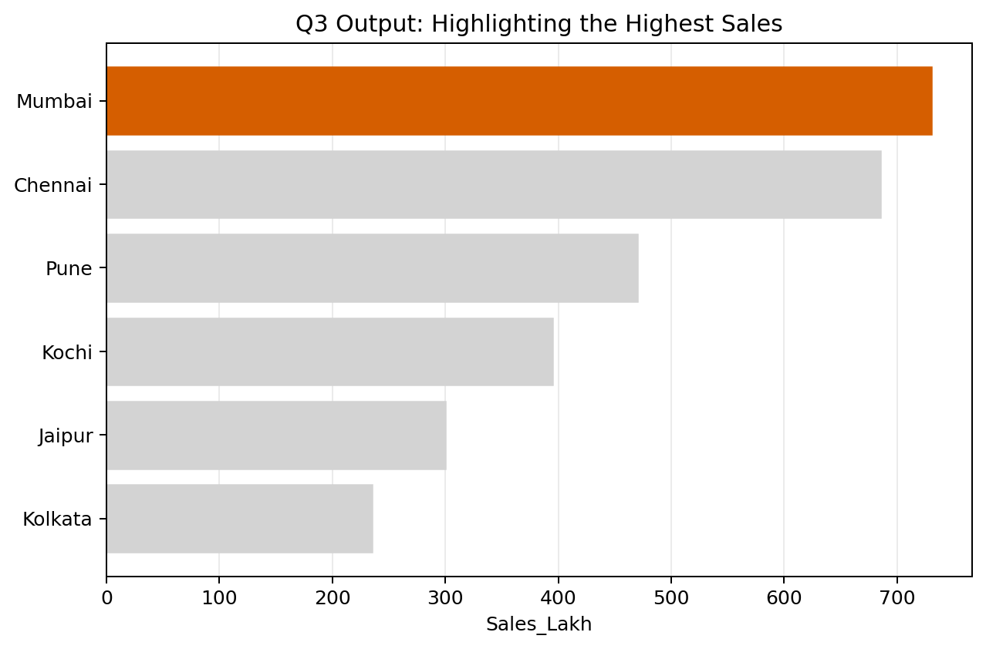

(b) Name the colour technique used and explain why the other bars are grey. [3]
- Technique: colour highlighting / accent colour.
- Mumbai has the highest sales (730 lakh), so it receives the accent colour #D55E00.
- The other bars are grey so they recede into the background and the reader's attention is directed immediately to the maximum.

Q4. Table to Visual: Cartesian versus polar coordinates [10 marks]
The table gives rainfall (mm) across 12 months of a year (a cyclical variable).

Given data
Month | Rainfall_mm
Jan | 60
Feb | 50
Mar | 50
Apr | 40
May | 60
Jun | 30
Jul | 50
Aug | 90
Sep | 30
Oct | 40
Nov | 100
Dec | 40

(a) Sketch a bar chart in Cartesian coordinates. [3]
- Month is placed on the x-axis and Rainfall_mm on the y-axis.
- Each vertical bar starts at zero and has height equal to the rainfall value.
- The highest bar is November at 100 mm; August is next at 90 mm.
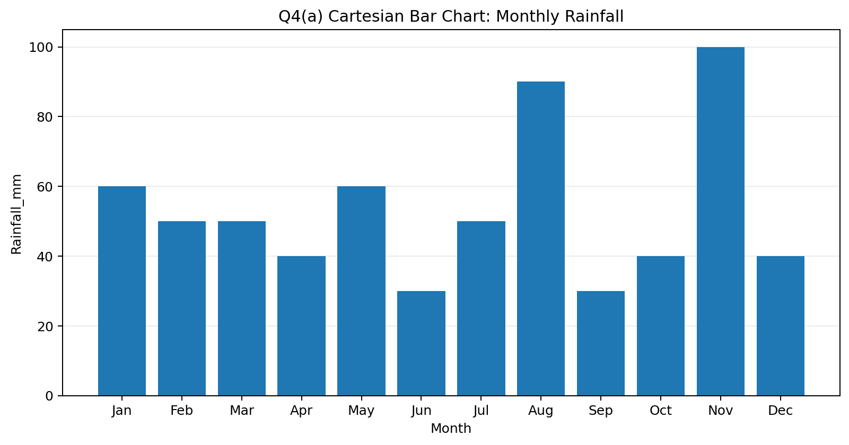

(b) Sketch the same data in polar coordinates (radial bars). State what angle and radius represent. [4]
- Each month is one equal angular sector: 360° ÷ 12 = 30°.
- Angle represents the month in the yearly cycle.
- Radius represents Rainfall_mm, from 0 to 100.
- The data values do not change; only the coordinate system changes.
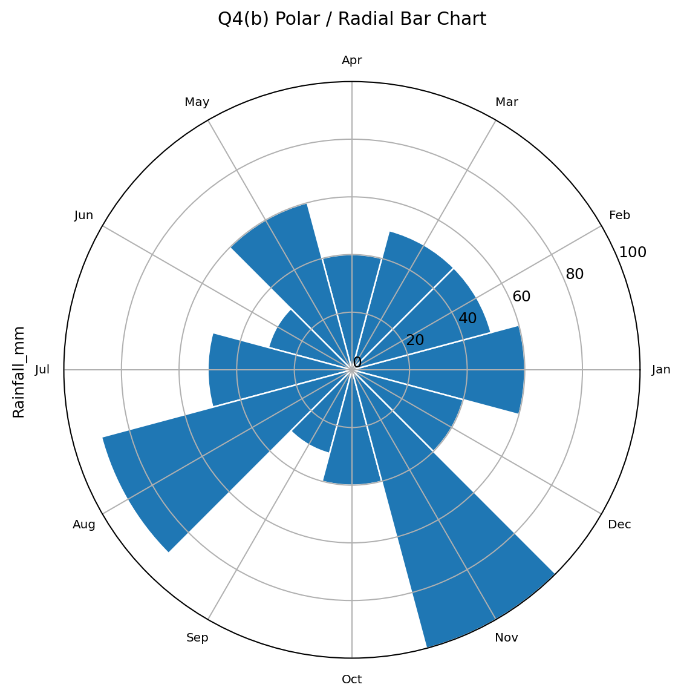

(c) Which coordinate system is better for this data? Give one advantage and one drawback of the polar version. [3]
- For comparing exact rainfall values, Cartesian coordinates are better because bar heights are easier to compare accurately on a common baseline.
- Advantage of polar coordinates: they emphasize the cyclical nature of the 12-month year.
- Drawback: radial bars make precise comparisons more difficult, especially for months near different angles.

Q5. Design Decision: Colour to distinguish and to highlight [10 marks]
A report compares 6 product lines in a bar chart. The reader's attention should go to the product line that missed its target. A colleague colours every bar with a different colour.

(a) Explain what is wrong with giving every bar a different colour. [3]
- Using a different colour for every bar makes all bars visually important.
- It creates unnecessary visual variety and increases the reader's cognitive load.
- Because the purpose is to identify the product line that missed its target, multiple bright colours weaken the intended visual hierarchy.

(b) Describe a better colour scheme: name the highlight colour and the colour of the other bars, with reasons. [4]
- Use one strong accent colour, such as orange (#D55E00), for the product line that missed its target.
- Use a neutral light grey (such as grey70) for all other product lines.
- The single accent colour creates a clear visual focus without implying that every category has a different meaning.
- The neutral grey background bars reduce distraction and make the missed-target product immediately noticeable.
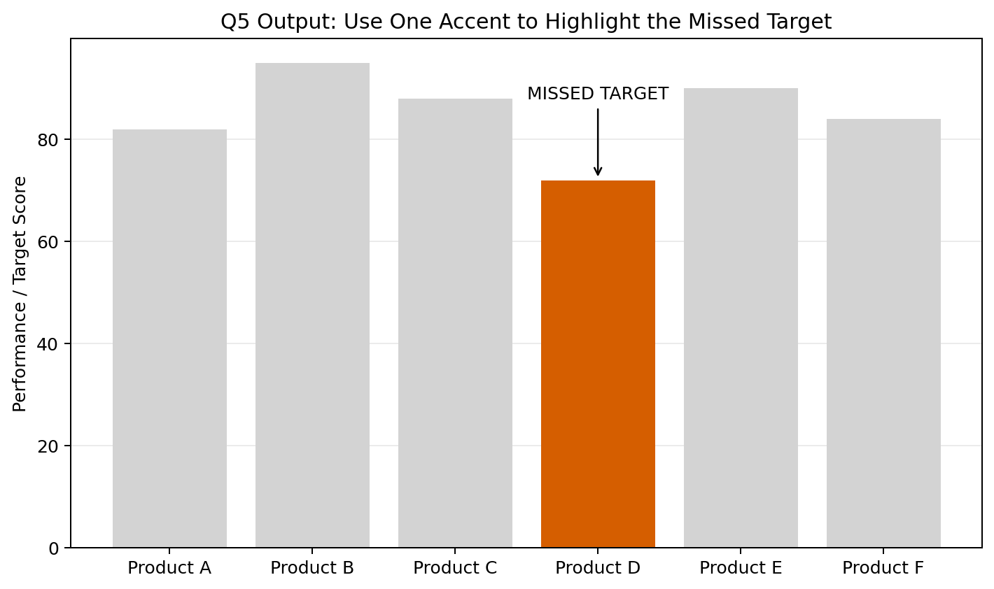

(c) Suggest one non-colour cue (e.g. annotation, label, order) that supports the highlight. [3]
- Add a direct text annotation such as “Missed Target” next to the relevant bar.
- A direct label is especially useful because it communicates the message even if the chart is printed in grayscale or viewed by a colour-blind reader.
- The highlighted bar can also be placed in a prominent order, but the annotation is the clearest supporting cue.

